**21CSAI01I**

**Introduction to Data Sciences**



**Project Proposal**

**By:**

**Group 19**

**Rawan Mohamed 193529**

**Mohamed Hesham Negm 206069**

**Dataset**

* Our datasets will be about crime rates in different counties in New-York state, US. One of the datasets will be about hate crimes in specific in theses counties, we plan to merge and analyse the two datasets to reach certain information about public saftey and targeted crimes in these locations.
* **Crimes:** <https://data.ny.gov/Public-Safety/Index-Crimes-by-County-and-Agency-Beginning-1990/ca8h-8gjq>

This dataset is **21.2K rows** and **15 columns**.

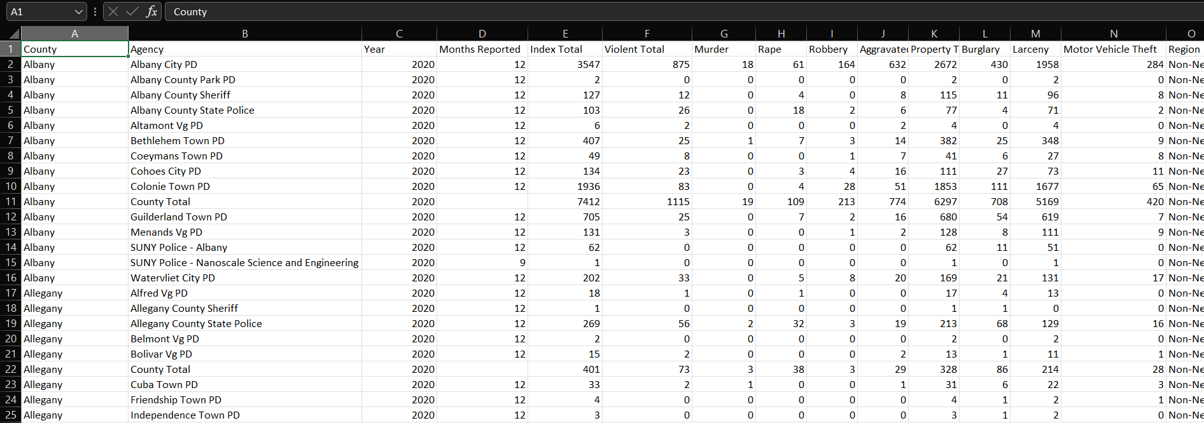

* **Hate Crimes:** <https://data.ny.gov/Public-Safety/Hate-Crimes-by-County-and-Bias-Type-Beginning-2010/6xda-q7ev>

This dataset is **673** **rows** and **44 columns.**

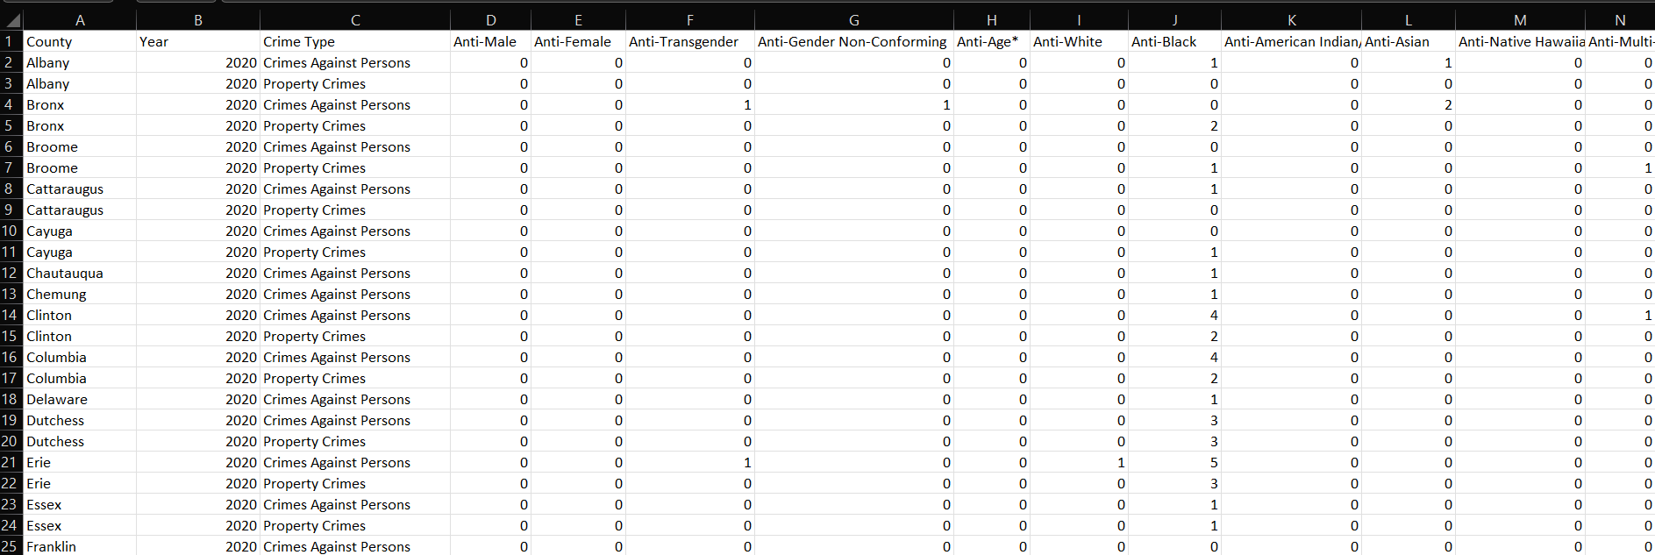

* We are expecting some difficulties merging and matching the data in theses datasets to prepare it for analysis as there are some missing attributes and mismatching ones.

**Goals:**

* We want to analyse the data so we can explore different issues about crime rates in these counties and how it affects the safety of certain groups. Some of the points we want to make include:

1. Did the covid-19 pandemic affect crime rates in these counties?
2. Did the change of the ruling party in the US affect hate crime rates?
3. How does the geographical location affect hate crimes against religious groups?
4. Do the counties with the most hate crimes have higher overall crime rate?
5. Is there a correlation between rape and gender hate crimes?
6. What counties have the most violent crimes reported in the 90s and in the 2010s? and Is the difference applicable to all other kinds of reported crimes?
7. Out of all anti-Jewish hate crimes, how many were against persons and how many were against property?
8. What are the total crimes reported in every county, per decade (1990s, 2000s, 2010s), and which decades had the least and most crimes.
9. What county had the least crime rate over the decades, therefore considered relatively safe to live in?